[ Insert official UPAEP logo ]
UPAEP · Decanato de Ingenierías
EVIDENCE — US01C-T2
Implement role-based access (RBAC) and redirection
SmartGreenAI: Cilantro Crop

1. Task information
Task ID | US01C-T2
User Story | US-01-C — Complete secure login and role-based access
Sprint | Sprint 2 (2026-09-21 – 2026-10-09)
Week | Week 1
Responsible | Alexis Enrique Valle Parra
Peer reviewer | Jorge Velez Delgado
Planned / actual hours | 1 h / 1 h
Completed on | September 25, 2026
Status | Done

2. Task description
Define the roles Administrator and Producer. Add route guards in the web app and a role check on the backend so each role is redirected to its own home page and cannot open pages or endpoints of the other role.

3. Completion conditions
✓ Condition 1: Roles Administrator and Producer exist in the DB and are assigned to test users.
How it was verified: The roles Administrator and Producer (plus Super Administrator, added for US-23/US-24) exist in the roles table, with their permissions in role_permissions. The test users admin@smartgreen.ai and producer@smartgreen.ai are assigned to them.
Roles in the database and the test users assigned to them (3 rows; US01C-T2_Implement_Role-Based_Access_RBAC_Redirection_1.csv)
role | description | test_user | is_active
Administrator | Operational configuration: producers, greenhouses, areas,… | admin@smartgreen.ai | true
Producer | Agricultural user: monitors the greenhouse, acknowledges … | producer@smartgreen.ai | true
SuperAdministrator | Platform-level administration: administrators, roles, ten… | superadmin@smartgreen.ai | true
SQL: SELECT r.name AS role, r.description, u.email AS test_user, u.is_active FROM roles r LEFT JOIN users u ON u.role_id = r.id ORDER BY r.name, u.email
Number of permissions per role (3 rows; US01C-T2_Implement_Role-Based_Access_RBAC_Redirection_3.csv)
role | permissions
Administrator | 40
Producer | 19
SuperAdministrator | 46
SQL: SELECT r.name AS role, COUNT(rp.permission_id)::int AS permissions FROM roles r LEFT JOIN role_permissions rp ON rp.role_id = r.id GROUP BY r.name ORDER BY r.name
✓ Condition 2: Each role is redirected to its own home page after login.
How it was verified: Each role signed in through the real login form. The page redirects every role to its own home (public/js/layout.js HOME map): Producer → /producer/, Administrator → /admin/, Super Administrator → /superadmin/.
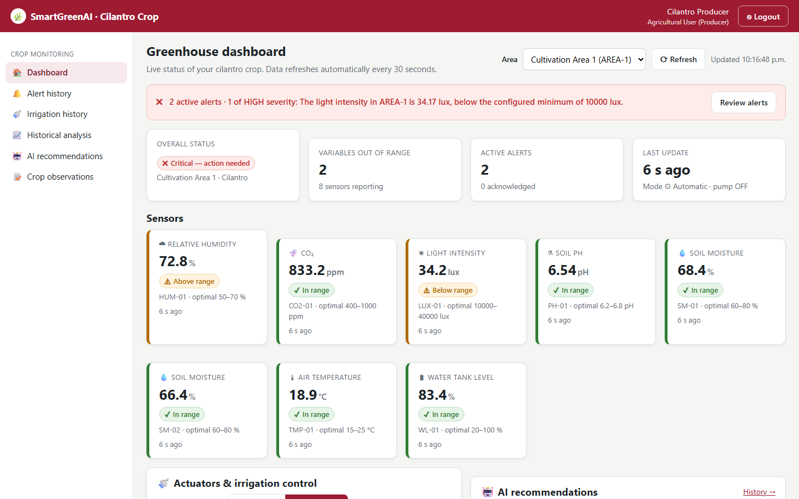
Figure US01C-T2-1. Producer signed in through the login form and was redirected to /producer/. (US01C-T2_Implement_Role-Based_Access_RBAC_Redirection_5.png)
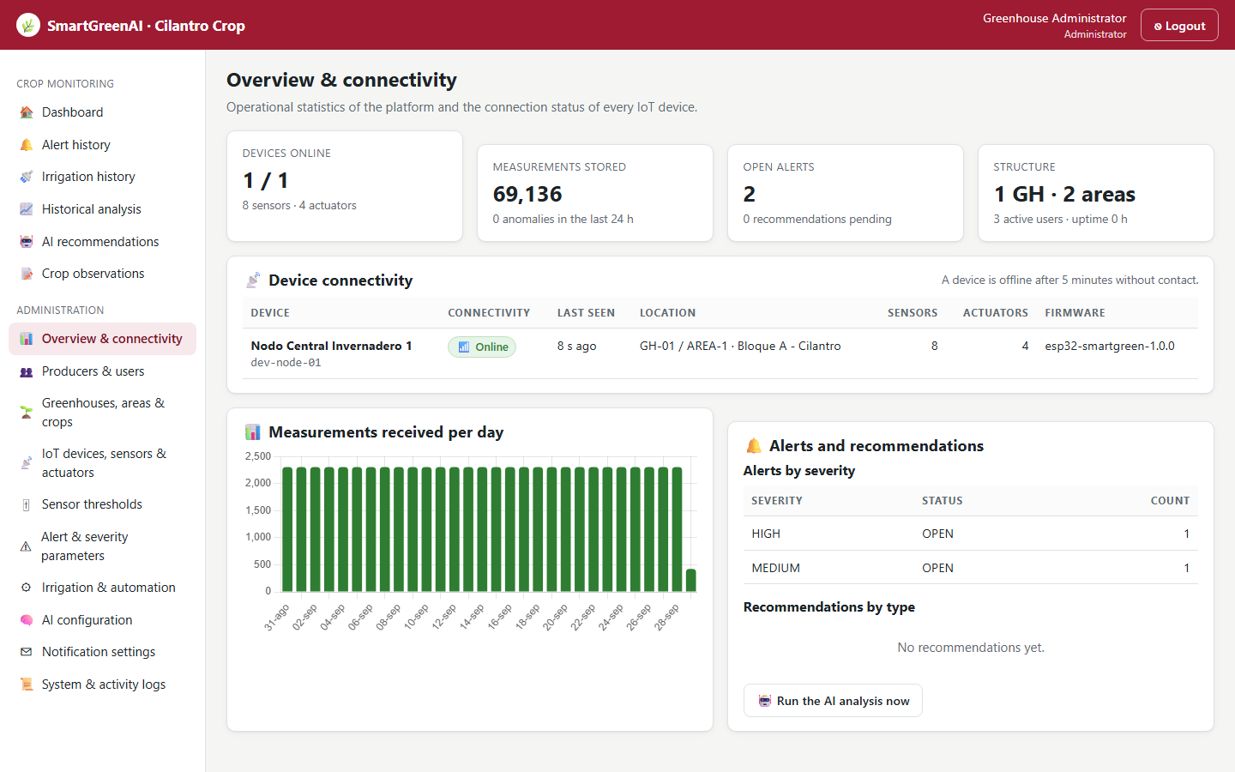
Figure US01C-T2-2. Administrator signed in through the login form and was redirected to /admin/. (US01C-T2_Implement_Role-Based_Access_RBAC_Redirection_6.png)
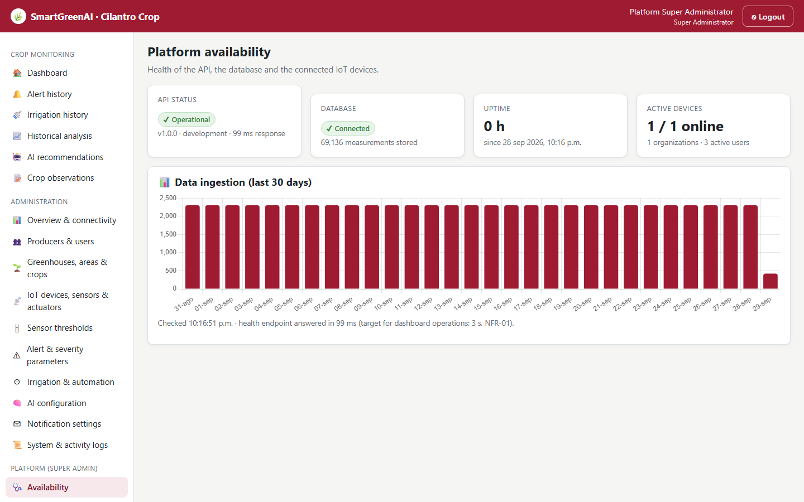
Figure US01C-T2-3. Super Administrator signed in through the login form and was redirected to /superadmin/. (US01C-T2_Implement_Role-Based_Access_RBAC_Redirection_7.png)
public/js/layout.js — lines 8–12
export const HOME = {
Producer: '/producer/',
Administrator: '/admin/',
SuperAdministrator: '/superadmin/',
};

✓ Condition 3: Backend returns 403 when a role calls an endpoint it is not allowed to use.
How it was verified: Every protected route declares the permission it needs (middleware/rbac.js requirePermission). The Producer calling user management, threshold updates or device registration, and the Administrator calling the Super-Administrator endpoint /admins, all receive HTTP 403 with code ERR_INSUFFICIENT_PERMISSIONS (403, 403, 403, 403).
Calls to endpoints the role is not allowed to use (attached: US01C-T2_Implement_Role-Based_Access_RBAC_Redirection_8.txt)
GET /api/users
Authorization: Bearer eyJhbG…
→ HTTP 403 Forbidden (11 ms)
{
"status": 403,
"code": "ERR_INSUFFICIENT_PERMISSIONS",
"message": "Your role (Producer) does not allow this operation.",
"details": [
{
"field": "permission",
"issue": "Missing permission: users.read"
}
]
}
PUT /api/thresholds/th-a1-soil-moisture
Authorization: Bearer eyJhbG…
{
"min_value": 60,
"max_value": 80
}
→ HTTP 403 Forbidden (11 ms)
{
"status": 403,
"code": "ERR_INSUFFICIENT_PERMISSIONS",
"message": "Your role (Producer) does not allow this operation.",
"details": [
{
"field": "permission",
"issue": "Missing permission: thresholds.write"
}
]
}
POST /api/devices
Authorization: Bearer eyJhbG…
{
"name": "Not allowed"
}
→ HTTP 403 Forbidden (11 ms)
{
"status": 403,
"code": "ERR_INSUFFICIENT_PERMISSIONS",
"message": "Your role (Producer) does not allow this operation.",
"details": [
{
"field": "permission",
"issue": "Missing permission: devices.write"
}
]
}
GET /api/admins
Authorization: Bearer eyJhbG…
→ HTTP 403 Forbidden (8 ms)
{
"status": 403,
"code": "ERR_INSUFFICIENT_PERMISSIONS",
"message": "This operation is restricted to: SuperAdministrator.",
"details": []
}

server/src/middleware/rbac.js — lines 18–39
function requirePermission(...codes) {
return (req, _res, next) => {
if (!req.user) return next(unauthorized());
const missing = codes.filter((code) => !req.user.permissions.has(code));
if (missing.length) {
return next(forbidden(
`Your role (${req.user.role_name}) does not allow this operation.`,
missing.map((code) => ({ field: 'permission', issue: `Missing permission: ${code}` })),
));
}
return next();
};
}
/** Require the user to hold one of the listed roles. */
function requireRole(...roleNames) {
return (req, _res, next) => {
if (!req.user) return next(unauthorized());
if (!roleNames.includes(req.user.role_name)) {
return next(forbidden(
`This operation is restricted to: ${roleNames.join(', ')}.`,

✓ Condition 4: Evidence: Each role lands on its correct page; restricted routes return 403 / redirect to login.
How it was verified: Each role lands on its own page (condition 2). Restricted routes answer 403 on the API (condition 3); in the web application, a page of another role redirects to the user's home, and a page opened without a session redirects to the login page.
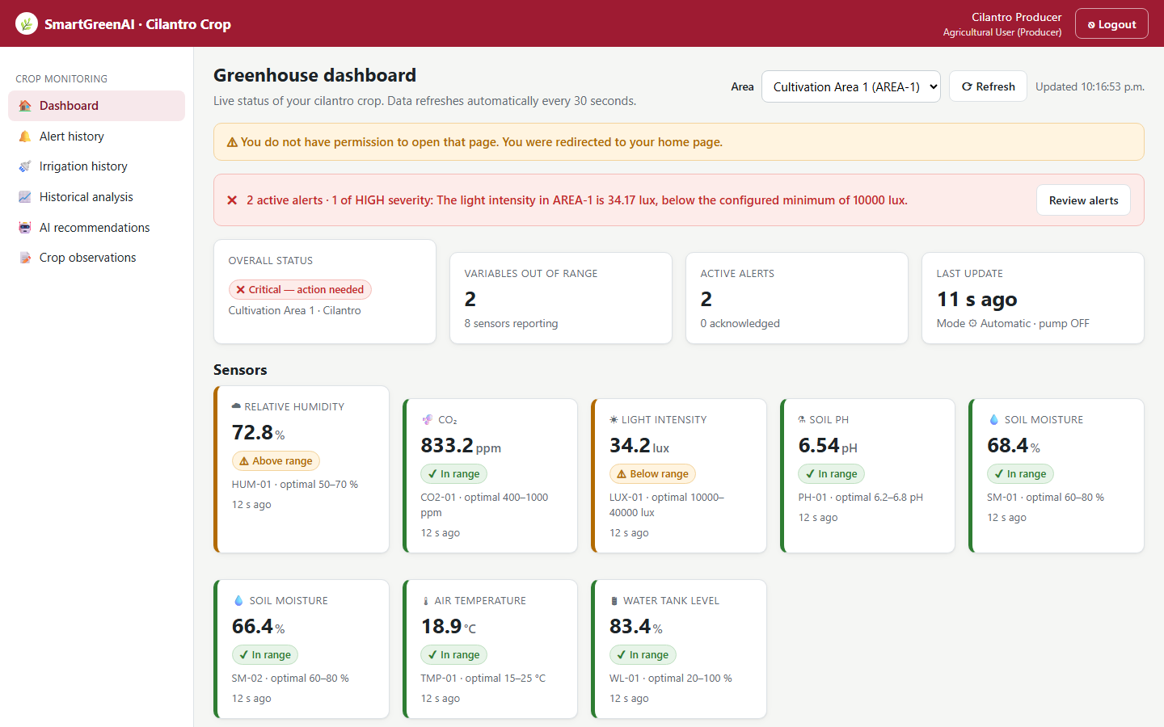
Figure US01C-T2-4. The Producer typed /admin/users.html: the route guard sent the user back to the producer home with a permission warning. (US01C-T2_Implement_Role-Based_Access_RBAC_Redirection_9.png)
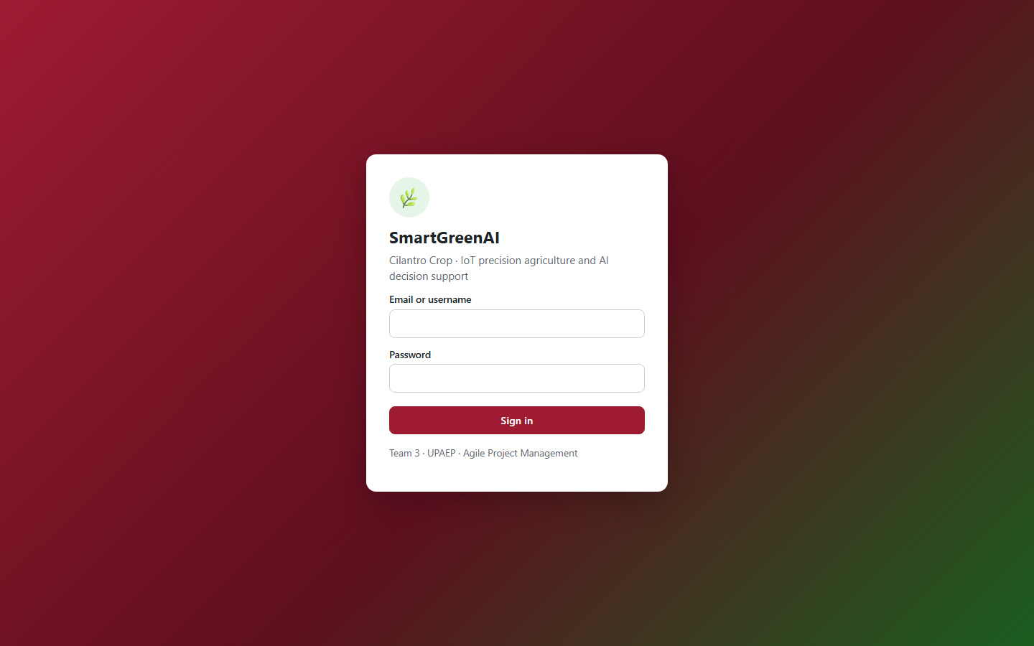
Figure US01C-T2-5. Without a session, /admin/thresholds.html redirects to the login page (/?next=%2Fadmin%2Fthresholds.html). (US01C-T2_Implement_Role-Based_Access_RBAC_Redirection_10.png)
public/js/layout.js — lines 65–89
export async function boot({ roles = ALL, active, title, subtitle }) {
if (!getToken()) { window.location.replace('/?next=' + encodeURIComponent(location.pathname)); return new Promise(() => {}); }
let me;
try {
me = await get('/auth/me');
} catch {
clearSession();
window.location.replace('/?expired=1');
return new Promise(() => {});
}
if (!roles.includes(me.role)) {
window.location.replace(`${HOME[me.role] || '/'}?denied=1`);
return new Promise(() => {});
}
document.title = `${title} · SmartGreenAI`;
const sidebar = h('nav', { class: 'sidebar', 'aria-label': 'Main navigation' });
for (const [section, items] of NAV) {
const visible = items.filter((i) => i[4].includes(me.role));
if (!visible.length) continue;
sidebar.appendChild(h('div', { class: 'section' }, section));
for (const [key, label, icon, href] of visible) {
sidebar.appendChild(h('a', { href, class: key === active ? 'active' : '' },

4. Attached files
- US01C-T2_Implement_Role-Based_Access_RBAC_Redirection_1.csv
- US01C-T2_Implement_Role-Based_Access_RBAC_Redirection_2.sql
- US01C-T2_Implement_Role-Based_Access_RBAC_Redirection_3.csv
- US01C-T2_Implement_Role-Based_Access_RBAC_Redirection_4.sql
- US01C-T2_Implement_Role-Based_Access_RBAC_Redirection_5.png
- US01C-T2_Implement_Role-Based_Access_RBAC_Redirection_6.png
- US01C-T2_Implement_Role-Based_Access_RBAC_Redirection_7.png
- US01C-T2_Implement_Role-Based_Access_RBAC_Redirection_8.txt
- US01C-T2_Implement_Role-Based_Access_RBAC_Redirection_9.png
- US01C-T2_Implement_Role-Based_Access_RBAC_Redirection_10.png

5. Traceability
Related requirements | FR-01, FR-02, FR-03, NFR-03, NFR-04
Implementation | See docs/TRACEABILITY.md
Verification | See docs/TRACEABILITY.md

6. Sign-off
Role | Name | Date | Signature
Responsible | Alexis Enrique Valle Parra | September 25, 2026
Peer reviewer | Jorge Velez Delgado | September 25, 2026
Product Owner acceptance | Alexis Enrique Valle Parra | September 25, 2026
Approval record: Daily Meeting 2 of Sprint 2 (Monday, September 28, 2026): "Review of the Week 1 milestone: US-01-C closed, API specification (US08-T1) shared on Wednesday, ER diagram and payload format approved." Decision: the firmware obtains UTC by NTP and sends recorded_at in ISO 8601; the server also stores received_at.

